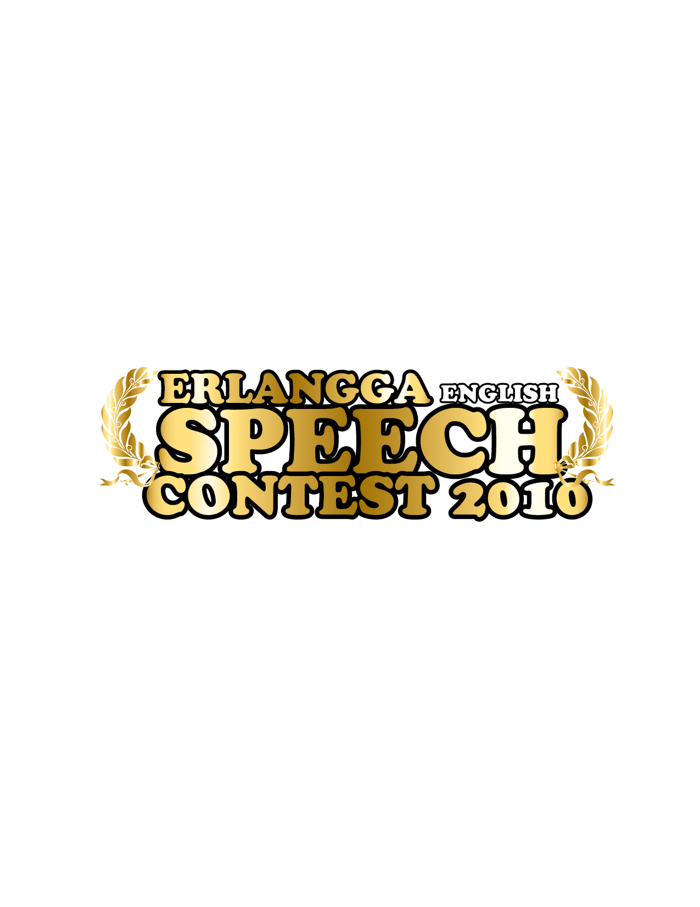

ERLANGGA ENGLISH SPEECH CONTEST 2010
for senior high school students (SMA/MA/SMK)
Jakarta, Bogor, Depok, Tangerang, Bekasi
Committee of Erlangga English Speech Contest 2010  Departemen Marketing Nasional
● Jl. H. H. Baping Raya No.100 Ciracas, Jakarta Timur 13740 Baping Ciracas Raya No.100, East Jakarta 13740  Phone: 021-8717006 ext. 228
● Fax: 021-87794609  erlangga.speechcontest@gmail.com
Atau melalui upload di:REGISTRATION FORM

Date : ______________________________________________________________________

Name: ______________________________________________________________________

Address: ____________________________________________________________________

Home Phone: ___________________________________ Cell Phone: ___________________

E-mail: _____________________________________________________________________

Age/Sex: __________________________ Grade/Program: ___________________________

School Address : _____________________________________________________________

School Phone : ___________________________________ Fax: _______________________

....................., ..................... ....................., ..................... 2010 2010
Signature

____________________________________________________________________________
If you are officially registering as a representative of your school, teacher or principal must sign.

